**How to Install AgentAssist for Zendesk**

The Kore.ai AgentAssist package is available on the Zendesk marketplace. After logging into the Zendesk account, you can install the package from the marketplace.

## Pre-requisites

Before you begin the installation, make sure you have the following information:

* Login credentials for your Zendesk account.
* Login credentials for AgentAssist.
* Chatbot details (Client ID, Client Secret, and BotID).

## Pre-Installation steps

Login to the AgentAssist account and find the chatbot details as shown below.

### **Step 1: Login into AgentAssist**

1. Visit <https://agentassist.kore.ai/koreagentassist/>.
2. Enter your email address and click **Continue**.  
   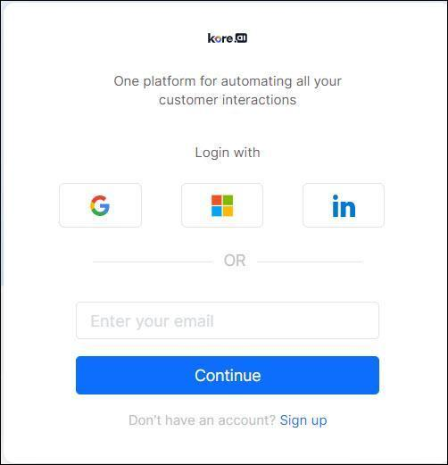
3. Enter the password and click **Sign In**.

For more details on Bot creation, refer to AgentAssist Documentation: <https://docs.kore.ai/agentassist/onboarding/creating-a-bot/>

### **Step 2: Finding the Chatbot details**

To find chatbot details (Client ID, Client Secret, and BotID):

1. Go to **Configuration** > **Channels** > **Chat**.

Auto-filled bot details appear.

1. Copy all the required bot information - Client ID, Client Secret, and BotID.

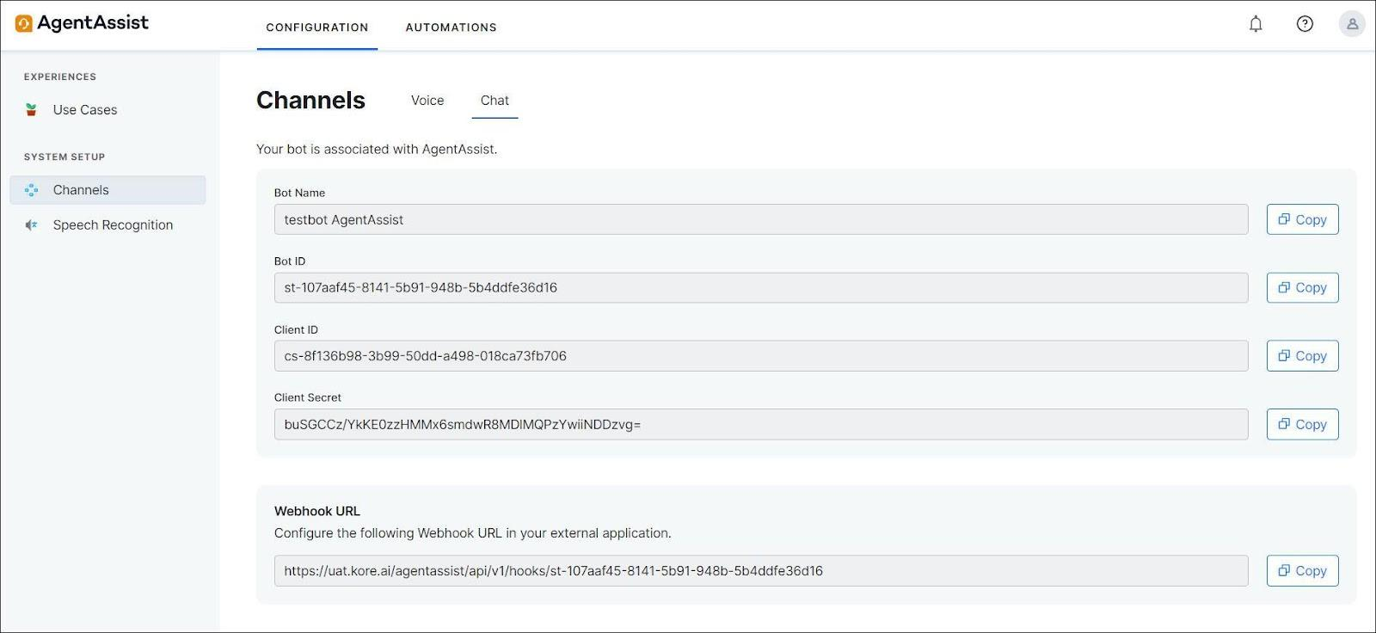

## Installing AgentAssist in Zendesk

1. Log in to your Zendesk account, find the **Kore.ai AgentAssist for Zendesk** package from the marketplace and click **Install**. The following Installation dialog is displayed.

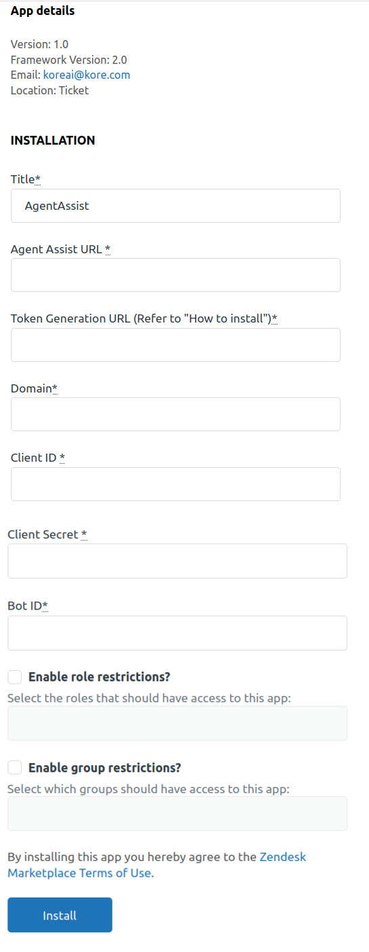

1. Enter or select the required information in the dialog:

* **Title:** By default, the title is AgentAssist.
* **AgentAssist URL:** You can find it from your Zendesk environment on the AgentAssist Configuration page.
* **Token Generation URL:** You can find it from your Zendesk environment.

There should be a REST service available with an implemented method of POST. The method should accept the body, as shown in the image below. Create a JWT token using the ClientID and the Client Secret.

You can have any service hosted on any cloud platform or the Zendesk environment.

The token generation URL is marked below:

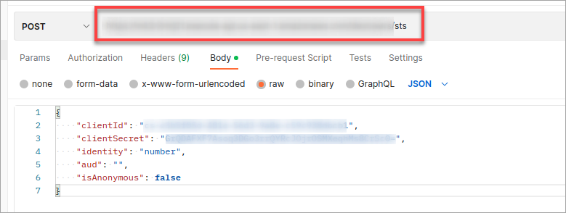

* **Domain:** In the earlier step, the domain name must be copied and pasted from the URL.
* **Client ID, Client Secret, and BotID**: Fill in the previously copied AgentAssist’s chatbot information in these fields. The same information that you copied in the pre-installation step.
* **Enable Role restrictions?** (optional) Select the Roles that should have access to the AgentAssist package.
* **Enable Group restrictions?** (optional) Select the Groups that should have access to the AgentAssist package.

3. Click **INSTALL**.

The AgentAssist widget is now available within Zendesk. Agents can start using the widget in Zendesk. Customer Onboarding includes logging into the Zendesk account, installing the AgentAssist package, initiating chat/voice, customization, and using the AgentAssist widget.

## Related links:

* [AgentAssist Widget](https://docs.kore.ai/agentassist/using/agentassist-widget/)
* [AgentAssist Features](https://docs.kore.ai/agentassist/using/agentassist-features/)